Photoshopping Assignment
Wendy’s Triple Burgler
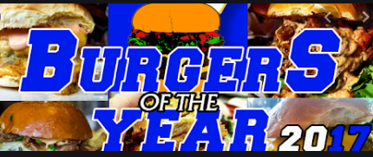

‘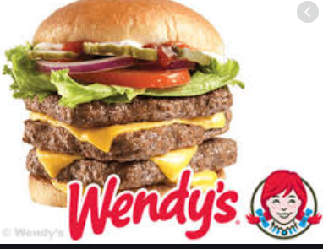
It is one of the decision and unhealthier menu that is within the firm. Researchers have shown that the cheese form of burger offers unhealthy honor basically at the fifth highest grossing food fast restaurants within the United State of America. In this connection, it is not regarded as one of the hard food substances that one could see. It is mainly stacked in between the premium bun of approximately ¼ pound patties, cheese slices, lettuce, mayonnaise, tomatoes, pickles, ketchup and onion. All its constitute makes it be delicious.
VW Beetle convertible
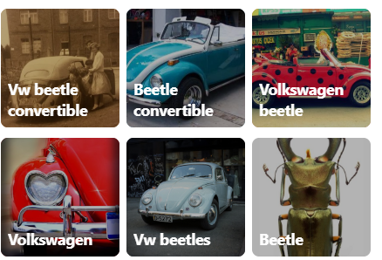
With the VW beetle convertible, it looks like an anthracite. It is one of the vehicles that are commonly used in the United State of American. There are ail owed by individuals from well-off families. They are mainly of different colours as the above ads depicts.
Sriracha2Go
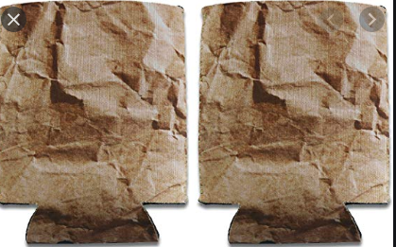
It is an insulated cooler whose size is approximately take as 12oz. It has a great form of the hot sauce lover form of gift and an insulated can cooler. This makes it be effective in the discharge of its duties.
Monster Energy Drink
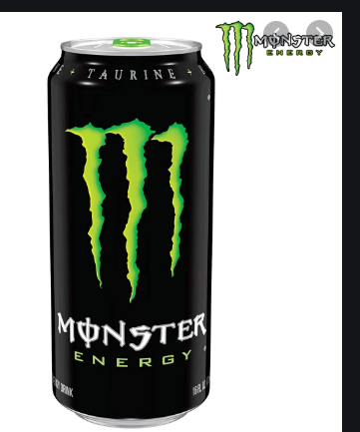
It is one of the cool used energy drink ever used by individuals as an energy supplementary food substances. It constitutes various energy giving food so as to offer the nutrients required in an individual’s body.
Samsung Phone
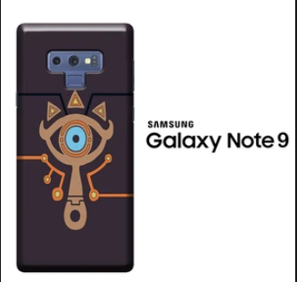
The ad above is commonly used by the sum sang company in order to advertise its product. The ad is please ad orally draws several buyers towards the purchase of the product. Other firms are advised to use a similar form of ad to popularize their products.

